
North Bengal International University

Lab Report: 03
Exp Name : K-Means Clustering

Subject : Artificial Intelligent sessional
Subject Code : CSE 0613-3112

Submitted By:
Name : Md. Tanvir Rahman Pranto
Dept : CSE
Roll : 0712340012101005
Semester : 3nd Year, 5th semester.

Submitted To:
Name : Rifa zumana
Designation : Lecturer
Dept : CSE
Date :

Tittle: K-Means Clustering
Theory: K-Means Clustering is an unsupervised machine learning algorithm used to divide data into different groups called clusters. It works by selecting a number of clusters (k) and then finding the best positions for the centroids of those clusters. Each data point is assigned to the nearest centroid, and then the centroids are updated based on the average position of the points in each cluster. This process continues until the centroids stop changing. K-Means helps to find patterns or group similar data points together without using any labels.

Code:
import numpy as np
import matplotlib.pyplot as plt

np.random.seed(42)
X = np.random.rand(1000, 2)

k = 5

centroids = X[np.random.choice(range(len(X)), k, replace=False)]

for i in range(10):

#step 1 :Assign each point to the nearest centroid..
distance = np.linalg.norm(X[:, np.newaxis]-centroids, axis=2)
cluster_labels = np.argmin(distance, axis=1)

#step 2 :Recompute
new_centroids = np.array([X[cluster_labels == i].mean(axis=0)
for i in range(k)])

#step 3 :Stop if centroid do not change
if np.all(centroids == new_centroids):
break

centroids = new_centroids

# plot the result
for i in range(k):
plt.scatter(X[cluster_labels == i, 0], X[cluster_labels == i, 1], label=f'cluster{i+1}')
plt.scatter(centroids[:,0], centroids[:,1], s=200, c='black', marker='X', label='Centroids')
plt.legend()
plt.title("K-means Clustering (from scratch)")
plt.show()

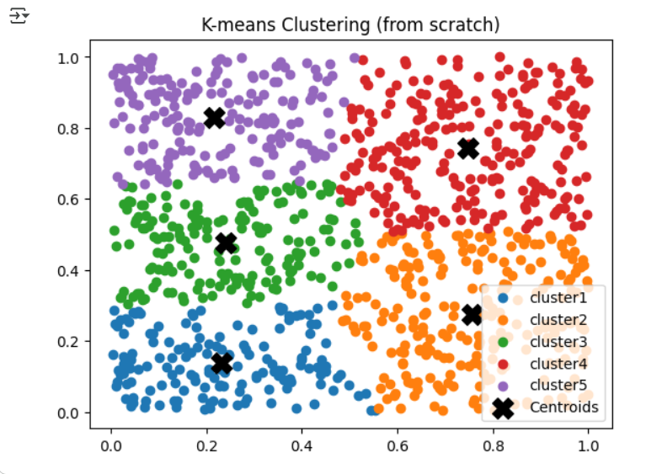
Output:

Conclusion: From this lab, we learned how K-Means Clustering divides data into groups based on their similarity. It shows how centroids move step by step until all data points are correctly grouped. This helps us understand the basic working process of clustering in machine learning.

